**BINARY SEARCH TREE**

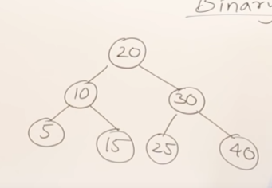The purpose of binary search tree is useful for searching elements are organized such that for every node on smaller element on the left hand side all the greater element on the right hand side so if you are searching smaller element u go left side if u search for bigger element u go to the right side.

**Best case** burada root elemanini bulmak best case=search for a root.

Dolayisiyla best case time=B(n)=1

**Worst case** = search for leaf element such as 5,15,25,40 If I am searching one of those elements than time will be maximum. What is worst case time worst case= w(n)=log n

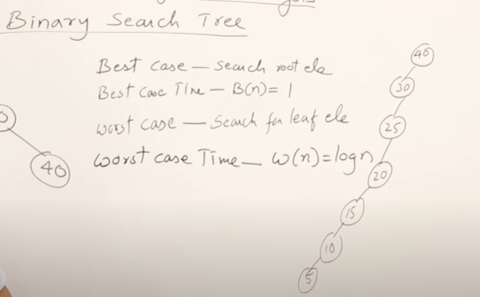

Binary Tree su sol taraftaki gibi de olabilir buna biz left skewed binary tree diyoruz.

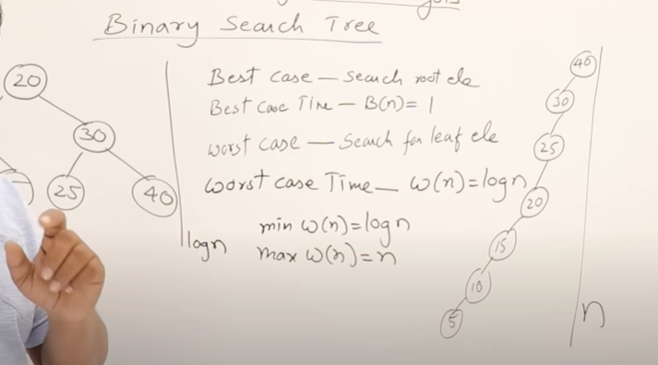

Su sarmasikli olanin time complexity si n iken high olanin log n minimum wors case ve minimum max case gelirsek

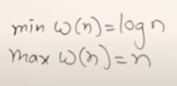

What is the worst case of time depends on height of a tree;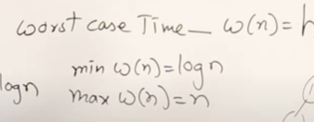

Eger yukarida gibi soldaki gibiyse log n ama sagdaki asagiya dogru iniyorsa dolayisiyla worst case Height ile baglantili ve agac ile baglantilidir diyebiliriz.